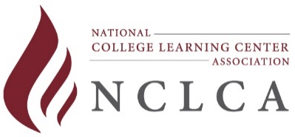
RENEWAL LEVEL 1 – Applicant’s Checklist Cover Sheet
Learning Center Leadership Certification
Name |  |  |  | Title
Institution
Address
City |  | State |  |  |  | Zip
Phone |  | Fax |  |  |  | E-mail

This is the checklist you will need to complete for your RENEWAL application for LEVEL 1 Learning Center Leadership Certification. Please provide a brief description of the new and/or additional information that you are including to support the criteria listed below. Use the tab labels listed below as you assemble your packet to provide reviewers with quick reference to your supporting documentation.

Level 1 Criteria | Description of  Supporting Documentation | Tab
Demonstrate understanding of the basics of learning assistance through either of the following options. You are not allowed to use the same documentation submitted for any previous applications. | Pick one of the two options below to rate.  Place N/A for the area not evaluated
Attendance at an applicable regional or national learning assistance conference/institute. Items to include:  - Registration receipt  - Website link or copy of program cover page including title, date, and location of conference. Screenshots of the website or digital guidebook are acceptable.  - Listing of the presentations attended – you may want to copy the program and highlight the sessions you attended (screenshots are acceptable). |  | A
Coursework in student development, learning assistance, developmental education, curriculum design, etc. Coursework can include:  - Tutor/peer training at the undergraduate level  - At least one course in student development, learning assistance, developmental education, curriculum design, etc.  Documented by academic transcript OR letter from instructor/department/ online service if audited/non-credit course |  | B
Any Additional Comments by Applicant:

Please respond to the following questions:
- I am a current NCLCA member in good standing __ Yes __ No
- The invoice # is ____ and will be paid via ___ Check, ___ PayPal, ___ Online Store
- For informational purposes, I authorize NCLCA to publish (in electronic and print formats) my name, level of certification, and other pertinent data related to NCLCA certification.

Signature Date

Revised 2/18/2021 by J. Haley

